26-2-4 Review: Trendline Failure in a Ranging Session

Market Environment: Typical Ranging Session
Today’s session is characterized by structural disorder and trend inefficiency. This type of market often creates the illusion of opportunity, while very few setups actually meet structural requirements.

ETH Overview
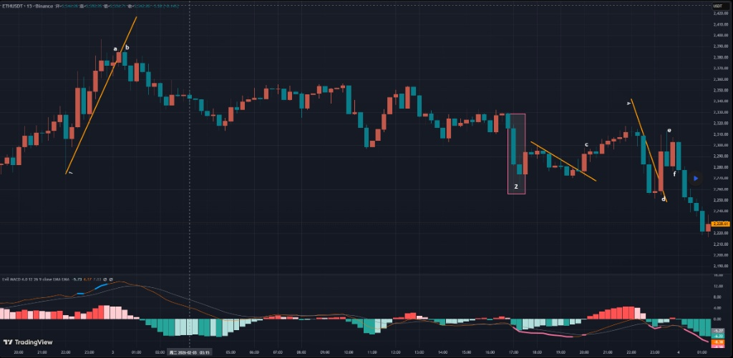

BTC Analysis
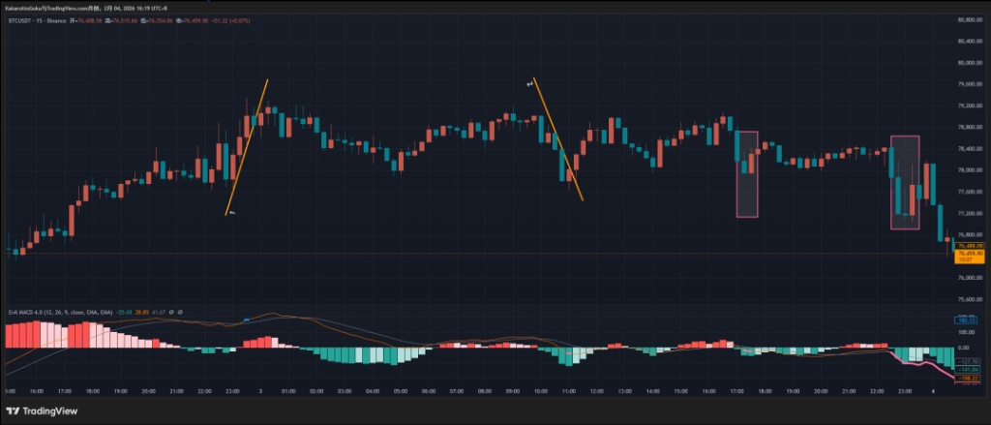
BTC displayed a classic intraday range structure. Several apparent “trendline” formations appeared on the chart, but they share the same structural issues:
• Trendline ①: Broke shortly after forming, without repeated market validation. This behaves more like structural noise than a confirmed trend.
• Trendline ②: Formation time was too short and lacked testing. Reversal probability at this level remains weak.
Two later zones showed bottom-type signals, but: Candle count insufficient | No valid trendline construction | Structural criteria not met.
Conclusion: Trendline methodology offered little practical value on BTC today. The session favored observation rather than participation.

ETH Analysis
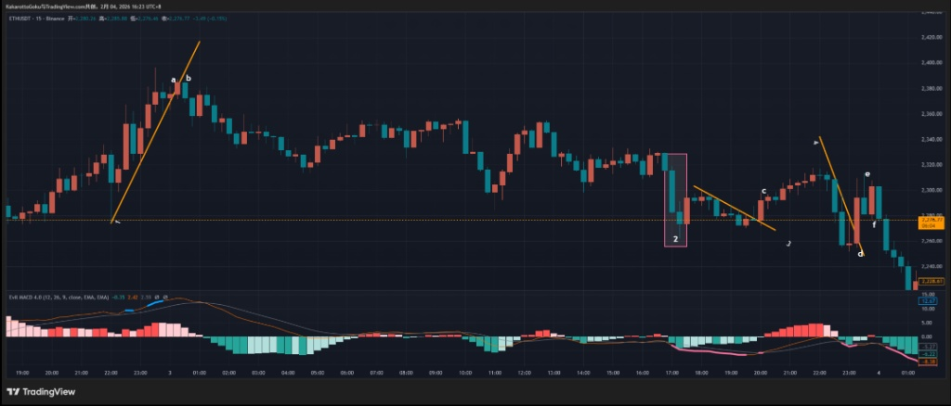
ETH showed slightly clearer structure than BTC, but still within a rotational environment.
• Trendline ①: Loss of structure at point A followed by a downside break at B. This confirmed a short-term bullish-to-bearish structural shift.
• Trendline ③: Upside break at C confirmed a bearish-to-bullish shift, but momentum sustainability was weak.
• Trendline ④ region: Candles D and E both printed upper wicks at nearly the same level, indicating supply repeatedly entered at the same resistance. The later reversal at point F aligns with this supply response.

Gold Analysis
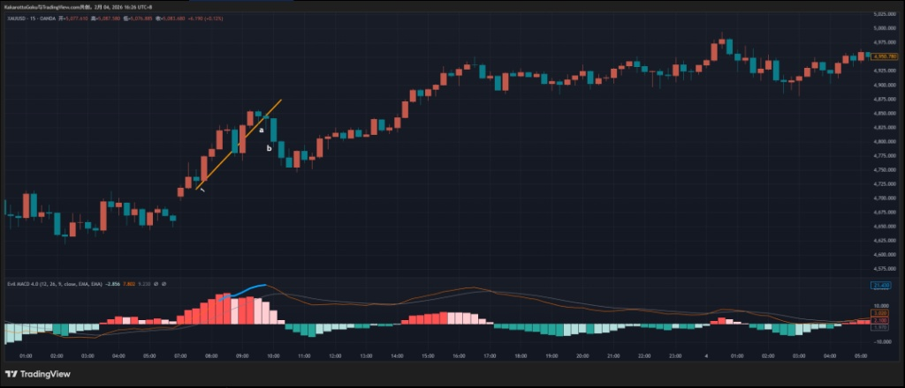
Gold showed a similar condition to BTC — limited structural opportunity.
• Trendline ① was only marginally valid. Temporary internal violations reduce its structural strength.
• Point A: The downside break candle showed a long lower wick and a near-bullish pinbar structure, representing a low-quality break.
• Point B: Waiting for confirmation significantly widened the stop distance, reducing trade efficiency.

Summary
Today’s market characteristics include frequent swings and many signals that appear valid but lack structural qualification. Trendline methodology weakened under ranging conditions. Non-participation aligns with structural discipline. The focus remains on waiting for clean structure to return.

